**LAB 08 TASK 1**

**Class Diagram of ATM MACHINE**

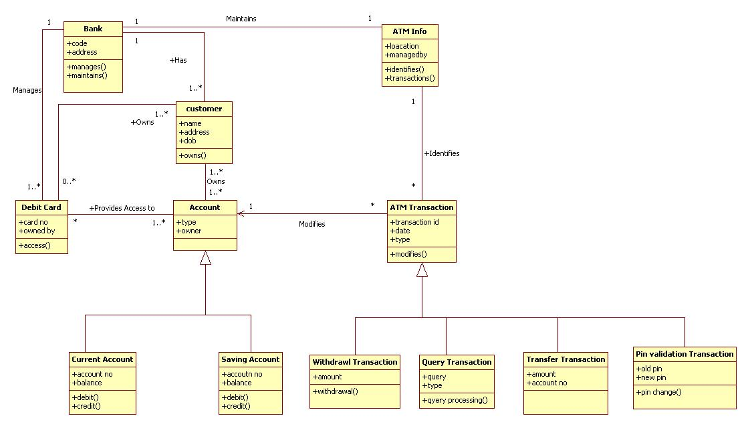

**LAB 08 TASK 2**

**Class Diagram of Library Management System**

